**React Native Localization**

Using multilanguage support in react native apps:

First, let's create and run your project:

npx react-native init localization –template react-native-template-typescript

Let's add react-native-localize and i18n-js libraries to our project.

yarn add react-native-localize i18n-js

yarn add -D @types/i18n-js

The react-native-localize library provides fetching information about the current language of the device. The i18n-js library, on the other hand, is required to transfer appropriate words for the specified languages ​​to the interface.

Now, in order for the word hello to be displayed in other languages; Let's create language files for English, Turkish and Arabic languages.

**Creating language files:**

For this, first let's create a directory named src/lang in the project directory and add the following language files:

**en.ts:**   **tr.ts:**

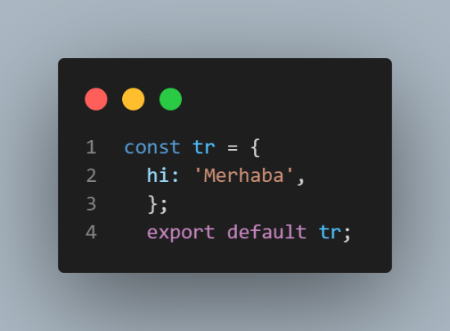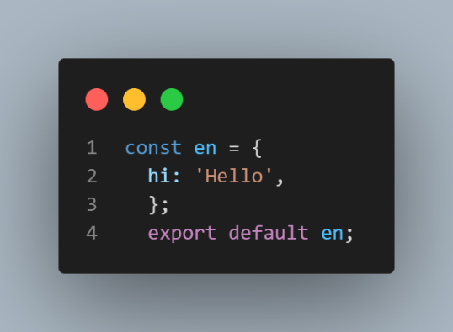

**ar.ts:**

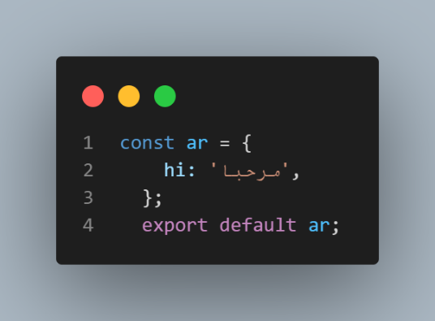

Then, let's create a file named **_i18n.ts** in the src/lang directory so that the appropriate file can be used according to the selected language on the device:

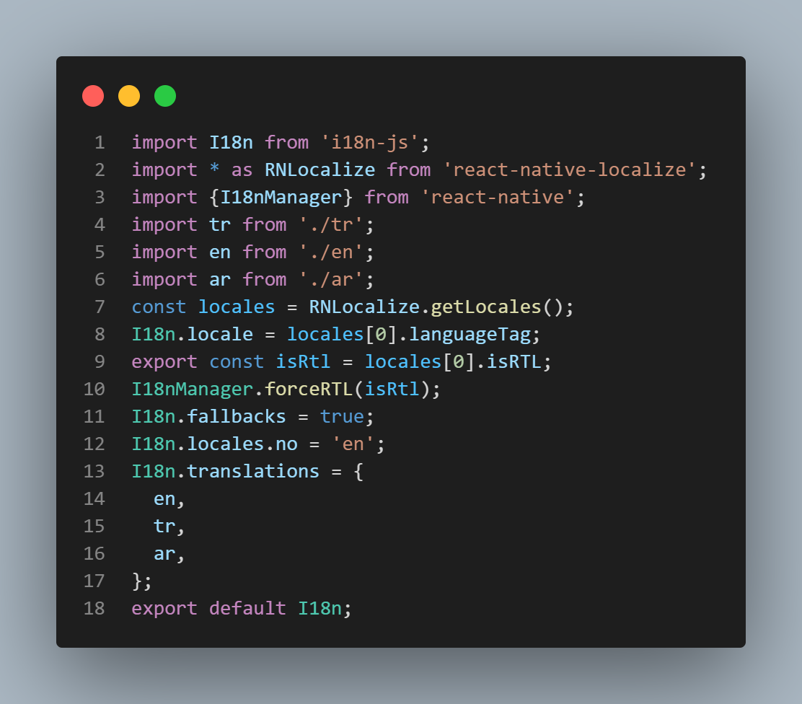

**RNLocalize.getLocales():**Brings up the preferred language list on the device.

**languageTag:** **Brings the language code such as en, tr or ar.**

**isRTL**: Indicates that the relevant language is written from right to left.

**forceRTL: It is to force the interface components to be lined up from right to left instead of left to right.**

**fallbacks=true:** Indicates that it should be compensated from the next language because no record of the specified language could be found.

**locales.no:** When the requested language is not found, the language to be compensated is specified instead.

**translations:** **It allows the languages ​​to be used in the application to be taken as objects.**

**Use of language files in the application:**

The simplest use of I18n is as follows;

**I18n.t('hi')**

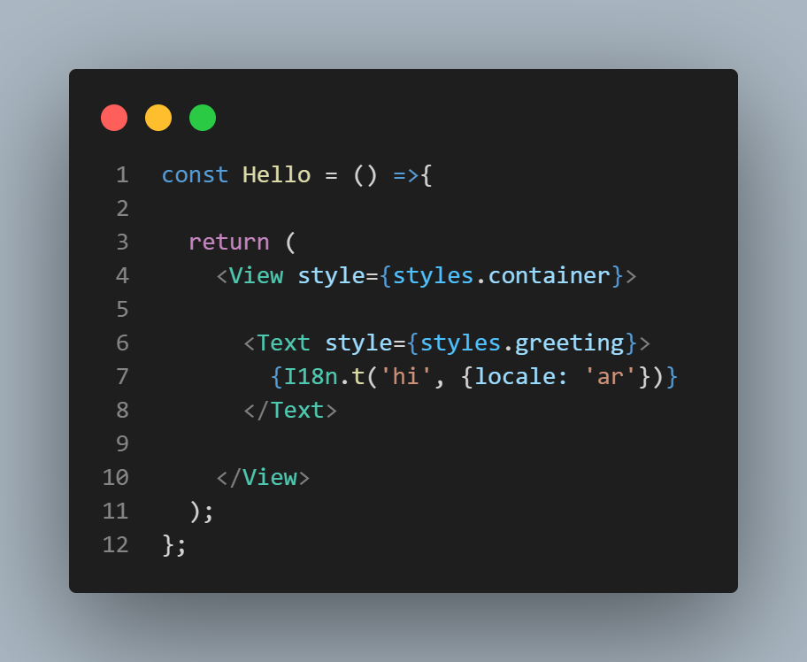We can use this function in App.tsx as follows ;

When you run the application, it will be displayed as follows according to the preferred language on your device.

**Optional language selection:**

**I18n.t('hi', {locale: 'tr'})**